ECM Service setup Server 2003

# Creating a Scheduled Task

1. Open Scheduler
2. Go to Start > Programs > Accessories > System Tools > Scheduled Tasks
3. Double-click Add Scheduled Task
4. The Scheduled Task Wizard will appear. Click Next.
5. Select the program to run. Choose your browser from the list (for example, Internet Explorer or Mozilla Firefox or in our case, EcmService.exe). Click Next.
6. Give the task a Name, such as ECM Auto-archive Job, and choose the Frequency with which to perform the task (for example, Daily). Click Next.
7. Choose specific date and time options (this step will vary, depending on the option selected in the previous step). When finished, click Next.
8. Enter your password if prompted. Change the username if required (for example, you'd like the task to run under a user with fewer privileges security reasons). Click Next.
9. On the final page, select the checkbox Open advanced properties for this task when I click Finish and click Finish.

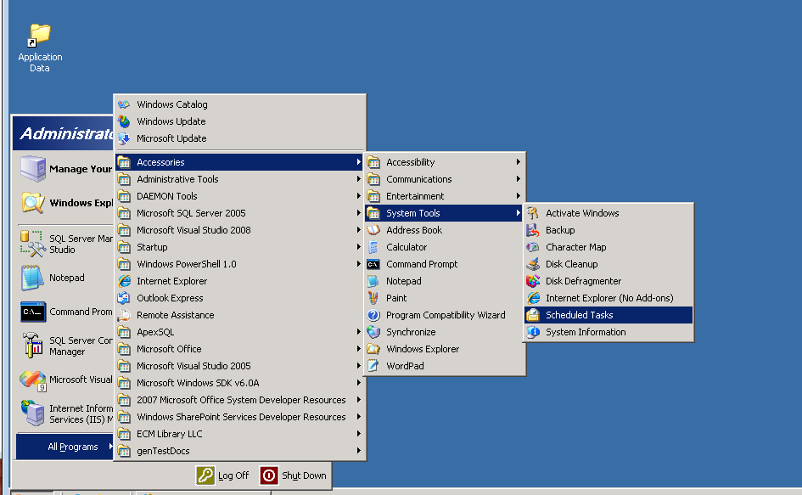

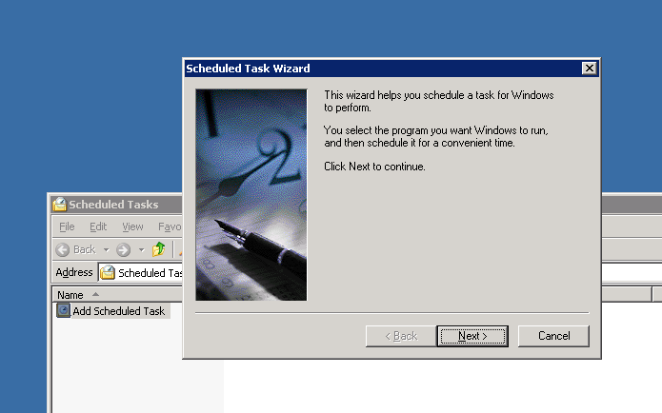

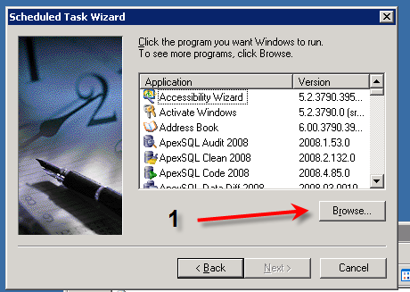

1. Find the ECM Auto-archive Application
2. Select it as the target application